Pilot implementation of Short Message Service for randomisation in a multisite pragmatic factorial clinical trial in Kenya (PRISMS Study)

Post Implementation report July 2022
Project Period: August 2020 – May 2022

Authors
Mercy Chepkirui Terer^{1,4}, Dennis Kimego¹, Dr. Charles Nzioki⁵, Dr. Elizabeth Jowi⁶, Charles Opondo^{2,3}, Ambrose Agweyu¹

Affiliations
- Epidemiology and Demography Department, KEMRI-Wellcome Trust Research Programme, Nairobi, Kenya
- National Perinatal Epidemiology Unit, University of Oxford, UK
- Department of Medical Statistics, London School of Hygiene and Tropical Medicine, UK
- KEMRI – Center for Global Health Research
- Machakos Level 5 County Referral Hospital.
- Mama Lucy Kibaki Hospital

Other Partnering Institutions
- The Global Health Network
- Trials Methodology Research Partnership (TMRP)

Table of Contents
Introduction 3
Study objectives 4
Methodology 4
Implementation phases 5
.i. Phase 1: Development phase 5
.ii. Phase 2: Pilot SMS randomization 6
.iii. Risk assessment 7
Dissemination 8
Seminars and webinars 8
Publication 8
Challenges 8
Study Impact on future clinical trials 9
Acknowledgments 9
References 9
Appendix 11
i. Budget expenditure 11
ii. Application manuals and study tools. 11
iii. Study timelines 12
iv. The KEMRI Scientific and Ethics Research Unit (SERU) letter of approval. 12
KEMRI/RES/7/3/1 January 25, 2022 13

Introduction
Randomization of participants in clinical trials has become the standard method of experimental control aimed at reducing selection bias and eliminating confounding from known and unknown factors¹. The process of randomization² generally involves two steps: (i) Generating an unpredictable random sequence, and (ii) Implementing the sequence in a way that conceals the treatment assigned to potential study participants until eligibility is determined³. Failure to achieve proper randomization and allocation concealment may result in biased estimates of treatment effects⁴ and potential loss of integrity of trial results.

Traditionally the use of sequentially numbered, opaque, sealed envelopes has been regarded an acceptable method for concealed allocation of interventions in trials. However, this method is now falling out of favor due to vulnerability to manipulation⁵. Sealed envelopes may also be damaged during shipping and at the point of storage. Filling and sealing envelopes also involve a time-consuming manual process which is prone to human error – particularly in large complex studies.

In response to the limitations of using sealed envelopes and inadequate methodological approaches in controlled trials, centrally administered web-based/telephone randomization is now increasingly preferred for allocation of subjects to interventions in large studies. However, this method is challenging to implement in many low-resource settings with weak communication infrastructure⁶ and poor internet connectivity.

An alternative random allocation approach that is affordable, auditable, and suitable for low-resource settings is the use of mobile phone-based Short Messaging Service (SMS). SMS is a method of communication that transmits text messages up to 160 characters in size between mobile devices, or from a computer to a mobile device. Bulk messaging is a method by which SMS text messages can be delivered to up to a million users synchronously minimizing delays and an overlap of requests. Text messaging has been used in clinical trials to reduce missed appointments⁷ and improve clinic attendance in clinical trials and as cost-effective intervention for managing patients with chronic illnesses^{8–11}. Access to mobile phone technology has rapidly expanded in developing countries^{12,13}.

Kenya is estimated to have 98% mobile penetration¹⁴. 96.1% of internet users connect through mobile devices. Device ownership statistic indicate 99.7% of internet users own a smart phone while14.4% own a featured phone¹⁵. The Communication Authority of Kenya (CAK)¹⁶ figures show that the volume of SMSs sent stands at approximately 12 billion per quarter, this shows that the number messages sent by Kenyans remains high for a span of more than 5 years. This is attributed to the nearly negligible cost of sending a message compared to the cost of internet bundles.

PRISMS project undertook a pilot comparative study of an SMS-based randomisation platform versus sealed opaque envelopes alongside a funded 3x2 factorial pragmatic randomized controlled trial¹⁷ which aims to recruit 4392 children with severe pneumonia aged 2-59 months at 12 hospitals in East Africa by competitive enrolment.

We developed an SMS-based method for random allocation of treatments.

Study objectives
General objective
To evaluate the feasibility and accuracy of randomization using text messaging through response time and correct treatment allocation.

Specific objectives
- To estimate the response time of SMS delivery for randomization requests
- To assess user experience for envelope randomization and SMS randomisation approaches.
- To determine allocation sequence concordance for envelope randomization and SMS randomisation approaches.

Methodology
We designed and developed a three-tier system consisting of a data layer, a business logic layer and an administrative interface. An Android app and plain text messaging were used to formulate text messages using a fixed syntax consisting of participant unique identifier, trial site, stratum and the trial name as input parameters. The business logic layer verified the input parameters and obtained an allocation from the data layer before returning a response to the sender through an SMS. The text response contained the details of the treatment allocation, the participant identifier and the randomization study staff. The system was designed to smartly detect duplicate attempts using unique patient identifiers.
The administrative dashboard was a one stop trial summary center where all transactions and randomization logs were monitored. It allowed administrators of the system to monitor SMS activities, managed users, track randomization and recruitment rate per site per strata.
The study was conducted in two sites of a multi-site factorial clinical trial in Kenya(SEARCH Clinical trial)¹⁷ involving two interventions with up to nine possible allocations. We evaluated the accuracy of treatment allocations against the master randomisation list for each randomisation message processed, and SMS latency in seconds.
A post-implementation survey was used to evaluate user feedback. We built a user feedback into the mobile application which was only activated after the pilot implementation was completed. Each user of the randomization module completed the questionnaire.

Implementation phases
This project was conducted in two phases, phase 1 and phase 2. Phase 1 involved the design and specifications of the SMS platform both in web-based, text -messaging and Android application. This application was completed and tested before it was rolled out on site in phase 2.

Phase 2 involved piloting at two public routine care hospitals, Machakos Level 5 and Mama Lucy Kibaki Hospitals in Kenya. The two sites were selected as SEARCH trial sites with the highest recruitment rates. 4 SEARCH trial clinicians carried out the text randomization; 2 clinicians were based in each site. All users were taken through a training on how to use the SMS randomization prior to piloting.

The SMS platform was implemented in two modes, through text messaging on both featured phones and smartphones through an android mobile application. SMS randomization was conducted alongside the tradition method (the use of envelopes). Randomization was the third trial step in the SEARCH trial where a treatment to be allocated to a participant was chosen.

The study received ethical approval from the KEMRI Scientific and Ethics Research Unit (SERU)- (Appendix iv).

Phase 1: Development phase

The SMS randomization platform was designed and developed in three tiers as shown in the Figure 1: SMS platform framework below.

The mobile application was developed using android, web-based platform was developed using PHP Laravel framework integrated with an SMS Application Programming Interface (API) from a local service provider. One local network was chosen for piloting due to cost related estimations.

The code base of this project is archived in GitHub link located here. The mobile application is yet to be published on play store.

The web-based administrative dashboard is locally hosted at the KEMRI-Wellcome Trust servers with data being managed as outlined by the study protocol. The code of the platform can still be accessible via the GitHub link listed above.

Figure 1: SMS platform framework
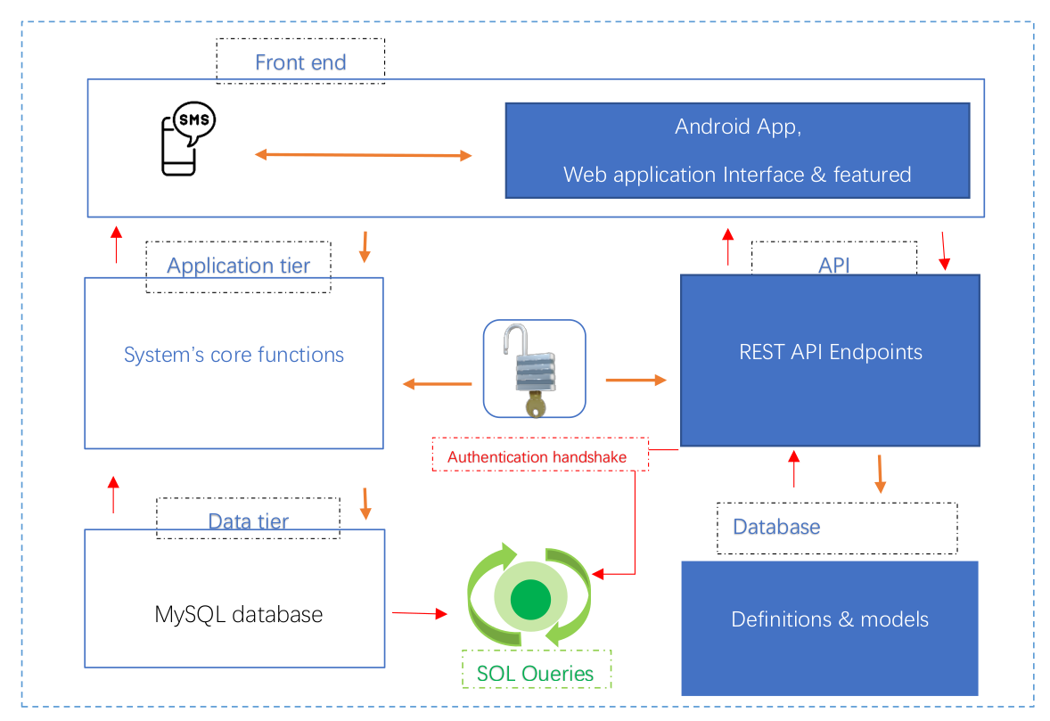

Phase 2: Pilot SMS randomization

A total of 219 participants were successfully randomized between February 2022 and May 2022. The participants were first randomized using envelopes as the first step then SMS randomization.

Each clinician was given a study tablet with a registered SIM card. The SMS application was installed on each of the tablets with each clinician having a separate account with a designated role to randomize participants. All system users were pre-registered in the database

A study clinician would screen patients for eligibility and proceed to randomize using the primary method(envelopes) then repeat the randomization using text messaging. The treatment allocated to the participant was based on the primary method.

An administrative dashboard was used to monitor trial randomization while managing the randomization sequence which was only uploaded once at the point of set up. (See the appendix ii for the detailed manual of the application).

The request was submitted in structured text format which was either manually typed or automatically formulated if one was using an android application. It took a clinician an average of 20 secs to type a text message with an average turnaround time of 38 secs to receive a response. We didn’t expect texting to interfere or delay care provision to a patient. In case of a system bug, the clinician was advised to provide care to the patient first before submitting a randomization request then give a call to user support for help. Treatment allocation was based on the primary envelope blinding method.

We had weekly review meetings where pilot progress and any arising issue was addressed.

Risk assessment
There was no risk for the participants involved since primary allocation of treatment was based on the existing method, the use of sealed envelopes. SMS randomization method was a pilot process which did not involve treatment allocation based on its sequence. Sending an SMS was free hence the system user would not incur any cost. The premium SMS subscription package under research cost covered all the SMS costs. We did not anticipate any inconvenience from the text messaging. The maximum length of the message was up to 6 words, and it took less than 1 minute to formulate a message. It would take a clinician less than 2 minutes to complete the process per participant. Text messaging was done after the participant had been allocated treatment using the primary method. The clinician would prioritize patient’s care in cases where the system delayed the response by proceeding to give the allocated treatment obtained from the enveloping process.

Results

A total of 219 participants were randomised between 7th February 2022 and 11th April 2022, out of which 180 were randomised to the first pair of treatments while 39 were randomised to both pairs of treatment. Allocation accuracy was 100%. Median latency was 21 seconds with the fastest message processed in 10 seconds and the slowest (non-network delayed) message processed in 96 seconds. A delayed response due to a failure within the mobile network was registered but was eventually delivered 35 minutes after it was requested. Four users completed a qualitative survey, three of whom preferred using the Android app over plain text messaging to send randomisation requests, while all users indicated preference for SMS randomisation over sealed envelopes.

Dissemination

Seminars and webinars
We were able to demonstrate SMS randomization in real time using plain texting, Android application and show-cased how the administrative dashboard processes each SMS randomization request. While undertaking this project we made a number of presentations listed below.

- TMRP UKTMN trials methodology webinar series in 2020 and 2022
- Kenya Medical Research Institute Annual Scientific Health (KASH) conference (2021) . Page 87, abstract number 46.
- Internal seminar at KEMRI - Wellcome Trust research Programme in July 2021.

An abstract to present at the upcoming ICTMC 2022 conference and the Global Health Network Conference 2022 was submitted and we hope to be selected to attend and share with global audience the outcome of this work.

Publication
We are in the processing of developing a manuscript that will be submitted to a peer-reviewed journal for publication.

The SMS platform code base is available on Github. We are exploring options to have the application published on play store to avail it to the public audience. In the meantime, it is available on the website link here.

Challenges

The COVID-19 pandemic greatly impacted the operations of this project. Recruitment of a
supporting software developer was delayed. Suspension of the SEARCH trial due to COVID-19 also delayed the pilot implementation and qualitative interviews which were planned to commence soon after Phase 1. However, we were granted an extension and managed to resume and successfully conclude study activities.

It has been challenge publishing the Android application on Google play store due to SMS permissions related reasons. We are exploring alternative means of publishing the application and avail to the public.

Study Impact on future clinical trials
Well conducted trials provide evidence for policy and guideline implementation in disease management, improvement of care and ultimate reduction of morbidity and mortality. The proposed solution offers a potentially more reliable and cheaper alternative to support increasing clinical trials in Sub-Saharan Africa. The study demonstrates the utility and cost advantage of randomization using text messages, future application of this method will improve the conduct of clinical trials.

Acknowledgments
This project would not have been possible without the kind of support and help of many individuals. We would like to extend our sincere gratitude to the following teams.
  - SEARCH clinical trial management and administration staff
  - Mama Lucy Kibaki Hospital study clinicians, pediatric team, and data clerks
  - Machakos Level 5 Hospital study clinicians, pediatric team, and data clerks
  - KEMRI – Wellcome Trust financial team
  - KEMRI – Wellcome Trust data team and ICT department
It has been a great honor to be funded as an early career researcher and this has been a great opportunity to kickstart the journey through The Global Health Network methodology hub and the MRC-NIHR Trials Methodology Research Partnership (TMRP).
The funders had no role in the conduct of the research and the findings do not necessarily represent the views of the funders.

References
1. Altman DG. A fair trial? BMJ. 1984;289(6441):336-337. doi:10.1136/bmj.289.6441.336
2. Kim J, Shin W. How to Do Random Allocation (Randomization). Clin Orthop Surg. 2014;6(1):103-109. doi:10.4055/cios.2014.6.1.103
3. Dettori J. The random allocation process: two things you need to know. Evid-Based Spine-Care J. 2010;1(3):7-9. doi:10.1055/s-0030-1267062
4. Moher D, Pham B, Jones A, et al. Does quality of reports of randomised trials affect estimates of intervention efficacy reported in meta-analyses? The Lancet. 1998;352(9128):609-613. doi:10.1016/S0140-6736(98)01085-X
5. Kennedy ADM, Torgerson DJ, Campbell MK, Grant AM. Subversion of allocation concealment in a randomised controlled trial: a historical case study. Trials. 2017;18(1):204. doi:10.1186/s13063-017-1946-z
6. Quaglio G, Dario C, Karapiperis T, et al. Information and communications technologies in low and middle-income countries: survey results on economic development and health (Part I). Health Policy Technol. Published online July 1, 2016. doi:10.1016/j.hlpt.2016.07.003
7. Junod Perron N, Dao MD, Righini NC, et al. Text-messaging versus telephone reminders to reduce missed appointments in an academic primary care clinic: a randomized controlled trial. BMC Health Serv Res. 2013;13:125. doi:10.1186/1472-6963-13-125
8. Chen Z wen, Fang L zheng, Chen L ying, Dai H lei. Comparison of an SMS text messaging and phone reminder to improve attendance at a health promotion center: A randomized controlled trial. J Zhejiang Univ Sci B. 2008;9(1):34-38. doi:10.1631/jzus.B071464
9. Finitsis DJ, Pellowski JA, Johnson BT. Text message intervention designs to promote adherence to antiretroviral therapy (ART): a meta-analysis of randomized controlled trials. PloS One. 2014;9(2):e88166. doi:10.1371/journal.pone.0088166
10. Park LG, Howie-Esquivel J, Chung ML, Dracup K. A text messaging intervention to promote medication adherence for patients with coronary heart disease: a randomized controlled trial. Patient Educ Couns. 2014;94(2):261-268. doi:10.1016/j.pec.2013.10.027
11. Thakkar J, Kurup R, Laba TL, et al. Mobile Telephone Text Messaging for Medication Adherence in Chronic Disease: A Meta-analysis. JAMA Intern Med. 2016;176(3):340-349. doi:10.1001/jamainternmed.2015.7667
12. Aker JC, Mbiti IM. Mobile Phones and Economic Development in Africa. J Econ Perspect. 2010;24(3):207-232. doi:10.1257/jep.24.3.207
13. Aranda-Jan CB, Mohutsiwa-Dibe N, Loukanova S. Systematic review on what works, what does not work and why of implementation of mobile health (mHealth) projects in Africa. BMC Public Health. 2014;14(1):188. doi:10.1186/1471-2458-14-188
14. Kharono B, Kaggiah A, Mugo C, et al. Mobile technology access and use among youth in Nairobi, Kenya: implications for mobile health intervention design. mHealth. 2022;8:7-7. doi:10.21037/mhealth-21-23
15. Digital in Kenya: All the Statistics You Need in 2021. DataReportal – Global Digital Insights. Accessed October 13, 2021. https://datareportal.com/reports/digital-2021-kenya
16. Mobile Penetration and Growth in Kenya. GeoPoll. Published January 13, 2021. Accessed October 13, 2021. https://www.geopoll.com/blog/mobile-penetration-kenya/
17. Agweyu A. Supportive Care and Antibiotics for Severe Pneumonia Among Hospitalized Children. clinicaltrials.gov; 2020. Accessed August 15, 2021. https://clinicaltrials.gov/ct2/show/NCT04041791

Appendix

Budget expenditure

Application manuals and study tools.
    - Android app SOP
    - Software specification document
    - Study consent form
    - Post implementation survey questionnaire

Study timelines
 | 2020 |  |  | 2021 |  |  |  | 2022
Tasks | Aug - Dec |  |  | Jan | Feb – May |  | June – Dec | Jan | Feb - May |  | June – July
Requirement specifications
Text-messaging development
Dashboard design
Phase 1 reporting
Android design
Testing
Protocol development
Protocol final approval
Piloting on site
End of project reporting
Manuscript development t(ongoing)

The KEMRI Scientific and Ethics Research Unit (SERU) letter of approval.

KENYA MEDICAL RESEARCH INSTITUTE

P.O. Box 54840-00200, NAIROBI, Kenya
Tel: (254) 2722541, 2713349, 0722-205901, 0733-400003, Fax: (254) (020) 2720030
Email: director@kemri.org, info@kemri.org, Website. www.kemri.org

KEMRI/RES/7/3/1 January 25, 2022

TO: MS. TERER, MERCY CHEPKIRUI, PRINCIPAL INVESTIGATOR.

THROUGH: THE DEPUTY DIRECTOR, CGMR-C,
KILIFI.
Dear Madam,

RE: KEMRI/SERU/CGMR-C/XXX/4359 (RESUBMISSION OF INITIAL
SUBMISSION): PILOT IMPLEMENTATION OF SHORT MESSAGE SERVICE FOR RANDOMISATION IN A MULTISITE PRAGMATIC FACTORIAL
CLINICAL TRIAL IN KENYA (PRISMS STUDY)"

Reference is made to your dated January 17, 2022. The KEMRI Scientific and Ethics Review Unit (SERU) acknowledges receipt of the revised study documents on January 18, 2022.

This is to inform you that the Committee notes that the issues raised during 318th Joint Committee A, B and C meeting of the KEMRI Scientific and Ethics Review Unit (SERU) held on December 14, 2021, have been adequately addressed.

Consequently, the study is granted approval for implementation effective this day, January 25, 2022, for a period of one year. Please note that authorization to conduct this study will automatically expire on January 24, 2023. If you plan to continue with data collection or analysis beyond this date, please submit an application for continuation approval to SERU by December 14, 2022.

Please note that only approved documents including (informed consents, study instruments, Material Transfer Agreement) will be used. You are required to submit any proposed changes to this study to SERU for review and the changes should not be initiated until written approval from SERU is received. Any unanticipated problems resulting from the implementation of this study should be brought to the attention of SERU and please, inform SERU when the study is completed or discontinued.

Prior to commencing you281r study, you will be expected to obtain a research license from National Commission for Science, Technology and Innovation (NACOSTI) https://oris.nacosti.go.ke and also obtain other clearances needed.

Yours faithfully,
PROF. CHARLES OBONYO,
THE ACTING HEAD,
KEMRI SCIENTIFIC AND ETHICS REVIEW UNIT.
In Search of Better Health

https://clinicaltrials.gov/ct2/show/NCT04041791
A feature phone is a type or class of mobile phone that retains the form factor of earlier generations of mobile telephones, with press-button based inputs and a small non-touch display. Also called dump phones.

